PROJECT DOCUMENTATION

- Title :- Amazon Product Data Analysis Using Python .

Submitted By :- Sujal Sudhakar Salvi .

Course :- Data Analytics .

Submitted To :- Prajakta Tayde .

- Introduction :-
In today’s online shopping world, platforms like Amazon provide a large amount of data related to products, prices, ratings, and customer reviews. Analyzing this data helps us understand product pricing, discounts, and customer feedback. In this project, I worked on an Amazon product dataset using Python. The main focus of this project is to clean the data, perform some basic feature engineering, and visualize the data in a simple way. This project helped me understand how real-world data looks and how basic data preprocessing is done before analysis.

- Objectives of the Project :-
- To understand the structure of a real Amazon product dataset.
- To clean price columns and convert them into numeric format.
- To perform simple feature engineering such as calculating discount amount.
- To categorize products based on their ratings.
- To visualize product price distribution using a basic graph.
- To gain hands-on experience with Python libraries like pandas and matplotlib.

- Dataset Description :-
The dataset used in this project contains information about different products available on Amazon. It includes details such as product name, category, prices, ratings, and customer reviews. The data was collected from an online source and stored in CSV format. Some columns in the dataset contained text values where numeric values were expected, especially in price and rating columns. Therefore, data cleaning was required before performing any analysis. This dataset is suitable for beginners as it helps in learning basic data cleaning, feature creation, and visualization techniques.

- Column Description :-

  - Product _id :- This column contains the unique ID given to each product on Amazon. It helps to identify every product separately, even if two products have the same name.

  - Product _name :- This column shows the full name of the product as listed on Amazon. It includes brand name and product details, which helps users understand what the product is.

  - Category :- This column represents the category to which the product belongs, such as electronics, accessories, home items, etc. It helps in grouping similar products together.

  - Discounted _price :- This column shows the current selling price of the product after applying the discount. It is the price that customers actually pay while purchasing the product.

  - Actual _price :- This column contains the original price of the product before any discount is applied. It helps in comparing how much price reduction is offered on a product.

  - Discount_percentage :- This column indicates the percentage of discount given on the product. It helps customers understand how much they are saving compared to the original price.

  - Rating :- This column shows the average customer rating of the product.
Ratings are usually given on a scale of 1 to 5 and represent customer satisfaction.

  - Rating_count :- This column represents the total number of users who have given ratings for the product. A higher rating count usually means the product has been reviewed by many customers.

  - About_product :- This column contains a short description of the product features and details. It helps customers understand the usage and benefits of the product.

  - User_id :- This column stores the unique ID of users who have reviewed the product. It helps in identifying different reviewers.

  - User_name :- This column contains the names of users who have written reviews for the product. It helps to know that reviews are given by real customers .

  - Review_id :- This column represents the unique ID assigned to each review.
It helps to identify individual reviews separately.

  - Review_title :- This column contains the heading or short title of the customer review. It usually summarizes the main opinion of the reviewer.

  - Review_content :- This column includes the full text written by customers about their experience with the product. It provides detailed feedback and helps other users make decisions.

  - Img_link :- This column contains the link to the product image available on Amazon. It helps in visually identifying the product.

  - Product_link :- This column provides the direct link to the product page on Amazon. It can be used to view or purchase the product online.

  - Discount_amount :- This column is created during data processing. It shows the actual amount saved by the customer, calculated by subtracting discounted price from actual price.

  - Rating_type :- This column categorizes products based on their ratings.
Products with rating 4 or above are marked as Good, and others are marked as Average. This makes rating analysis easier.

- Dataset Analysis :-
- Rating Column Data Cleaning :-
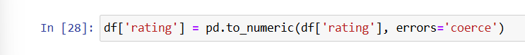
Explanation :-
In this step, the rating column is converted into numeric format.
Earlier, some rating values were stored as text, which can create problems during analysis. This conversion helps in performing comparisons and calculations on ratings. If any value cannot be converted into a number, it is automatically replaced with a missing value. This step makes the rating data clean and ready for further processing.

- Cleaning and Converting Discounted Price Column :-
Explanation :-
In this step, the discounted _price column is cleaned and converted into numeric format. The prices were originally stored as text because they contained the rupee symbol (₹) and commas. First, the rupee symbol is removed, and then commas are removed from the values. After cleaning the text, the values are converted into float type so that calculations can be performed. This step is important for price comparison, discount calculation, and further analysis.

- Cleaning and Converting Actual Price Column :-
Explanation :-
In this step, the actual_price column is cleaned and converted into numeric format.
Originally, the values in this column contained the rupee symbol and commas, so they were treated as text. First, the rupee symbol is removed and then commas are removed from the price values. After cleaning, the column is converted into float type, which allows mathematical operations. This step helps in comparing prices and calculating discounts accurately.

- Creating Discount Amount Column :-
Explanation :-
In this step, a new column called discount_amount is created. This column shows how much money a customer saves on each product. The discount amount is calculated by subtracting the discounted price from the actual price. This makes it easier to understand the real benefit of the discount offered on products. This newly created column is useful for price comparison and discount analysis.
- Creating Rating Category Column :-
Explanation :-
In this step, a new column called rating_type is created based on product ratings. If a product has a rating of 4 or higher, it is labeled as Good. If the rating is below 4, it is labeled as Average. This helps in understanding product quality easily without looking at exact rating numbers. This column makes rating analysis simple and more readable.

- Encoding Categorical Data Using Get Dummies :-
Explanation :-
The category column in the dataset contains text values that represent different product categories. Since text data cannot be directly used in most analytical and machine learning processes, it is converted into numeric form using the get_dummies method. This method creates separate binary columns for each unique category, where 1 represents the presence of that category and 0 represents its absence. The drop_first=True parameter is used to remove one category column in order to reduce redundancy and avoid duplicate information. This step helps in transforming categorical data into a structured numeric format, making the dataset ready for further analysis or modeling.

- Merging Encoded Category Data with Original Dataset :-
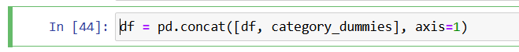
Explanation :-
After converting the category column into numeric form using get_dummies, the newly created dummy columns are merged with the original dataset. The pd.concat() function is used to combine both dataframes. By setting axis=1, the dummy variables are added as new columns instead of rows. This step ensures that all original product information and encoded category data are available in a single dataset.
The final dataset becomes more structured and suitable for analysis or future machine learning tasks.

- Histogram of Discounted Price Distribution :-
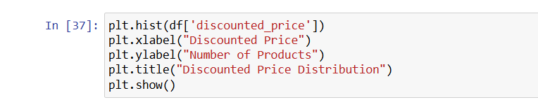
Explanation :-
In this step, a histogram is created to understand the distribution of discounted prices. The graph shows how many products fall into different price ranges. The X-axis represents the discounted price of products, while the Y-axis shows the number of products. This visualization helps in identifying whether most products are low-priced or high-priced.
Using this graph, we can easily understand the overall pricing pattern in the dataset.

- Bar Chart of Product Rating Types :-
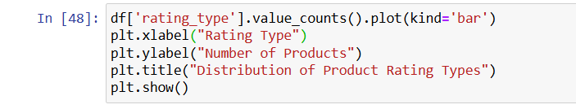

Explanation :-
This graph is used to understand how products are distributed based on their ratings.
In this chart, products are divided into two groups: Good and Average, which were created earlier using the rating column. The X-axis shows the rating type of products, while the Y-axis shows the number of products in each category. This makes it easy to see how many products are well-rated and how many are average-rated. From this graph, we can quickly understand the overall quality of products in the dataset. If the Good bar is higher, it means most products have received good ratings from customers. This visualization helps in summarizing rating information in a simple and clear way.

- Conclusion :-
In this project, Amazon product data was analyzed using Python.
The dataset was cleaned by converting text values into numeric format and handling unwanted symbols. New columns were created to make the data easier to understand, such as discount amount and rating category. Basic visualizations were also used to understand price distribution clearly. Overall, this project helped in learning data cleaning, feature engineering, and basic data analysis using Pandas, NumPy, and Matplotlib. This analysis makes the dataset ready for further insights and advanced analysis in the future.

